**248 FROM BASE 10 TO 2:**

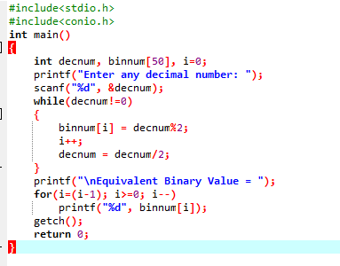

**OUTPUT**

